# **CHAPTER 1**

# **INTRODUCTION**

## Background of Wind Energy Harvesting

Although for thousand years of utilization of windy energy for basic applications like windmills and water pumps, utilization of wind for energy harvesting is never preferred because of its fluctuating and unknown nature. Like many developments in technology, modern wind energy utilization by means of wind turbines started 40 years ago due to search for alternative energy sources except oil, whose deficiency and high prices were a global crisis issue. Besides, air pollution and other environmental problems made it indispensable to search for clean and renewable energy sources such as wind. To summarize, OPEC crisis in 1970s and environmental problems worked as a catalyst in development progress of wind turbines. At first times of development, all the countries excluding Denmark tried to produce these wind turbines by experiences used in aerospace technology which has very high power ratings of MWs. After the understanding of the fact that produced turbines were bulky and inefficient in terms of reasonable cost of energy and required technology is different than the one used in airplane motors, all governments started to follow Denmark’s path. Denmark started the wind turbine technology by developing small wind turbines first and encouraged the individuals and small companies. These first turbines were operating at fixed speed and their structure was very simple. This concept of Squirrel Cage Induction Generator (SCIG) was called later as “Danish concept” and became a milestone for modern wind turbines. Today, more than 40 per cent of Denmark’s energy supply comes from wind power and the plan is to reach 50 per cent by 2020, as set out in the 2012 Energy Act. Total wind energy capacity in Denmark was 4,890 MW by the end of 2014, 3,620 MW onshore and 1,271 MW offshore [8]. Denmark has some of most important wind energy manufacturers worldwide such as [Vestas](https://www.vestas.com/) and [Bonus Energy A/S-lately was acquired by Siemens](http://www.energy.siemens.com/hq/en/renewable-energy/wind-power/). Nowadays, there are different types of wind turbines exist in the market both in mechanical and electrical aspects. Global trend is going above 5MW of output power and especially generator technologies are under development in order to maximize produced energy [25-27].

Global annual and cumulative installed wind capacities between 2001 and 2016 are given in Fig. 1-1 and 1-2, respectively. As it can be seen from graphs, wind energy harvesting has an increasing trend.

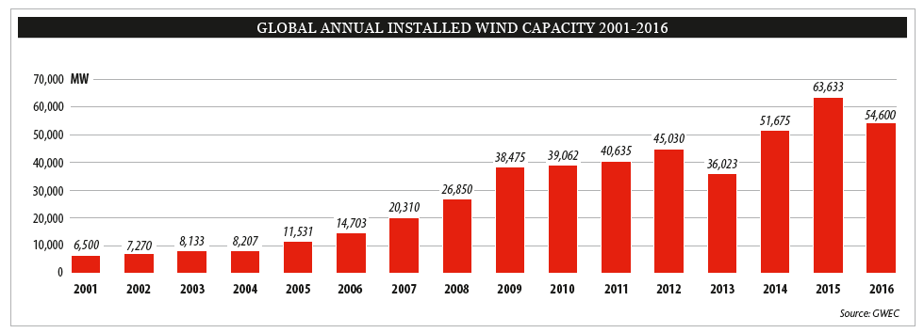

Fig. 1‑1. Global annual installed wind capacity 2001-2016 [23]

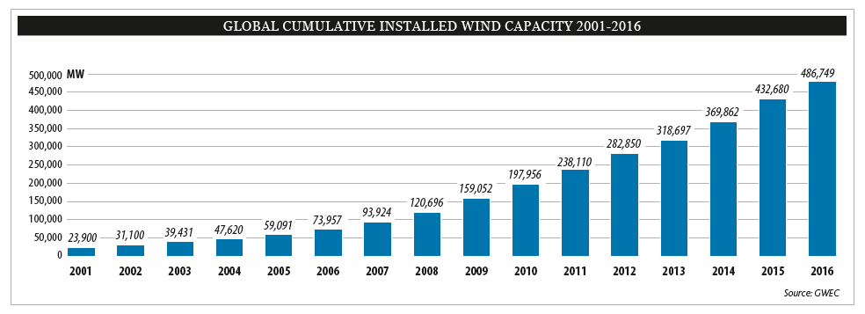

Fig. 1‑2. Global cumulative installed wind capacity 2001-2016 [23]

According to annual market update report of GWEC, it’s expected to reach 791 GW of global cumulative wind energy capacity by 2020, although it’s estimated that annual capacity growth rate will be stabilize around five percent level. Detailed market forecast of GWEC for 2016-2020 is given in Fig. 1-3.

Increase in utilization of wind energy in Turkey is very similar to global trends. Wind power supplied about 6% of Turkey’s electricity consumption in 2015 [7]. Turkey has nearly stable increase rate of installation rate of wind power plants for past 5 years. Fig. 1-4 shows the variation of cumulative installations for wind power plants in Turkey. Fig. 1-5 shows the global statistics of top 10 new installed capacity between January-December 2016. According to TWEA, it’s expected to reach total installed capacity of 10 GW, under the current regulatory framework. Turkey’s wind resources are estimated at more than 48 GW from areas with over 7 m/s wind speed at 50 meters height [7]. According to Renewable Energy Law, newly installed power plants are encouraged financially to come into operation by long-term (10 years) constant feed-in tariffs and additional bonus of up to USD 3.7 cent/kWh for using locally manufactured wind power plant parts [7].

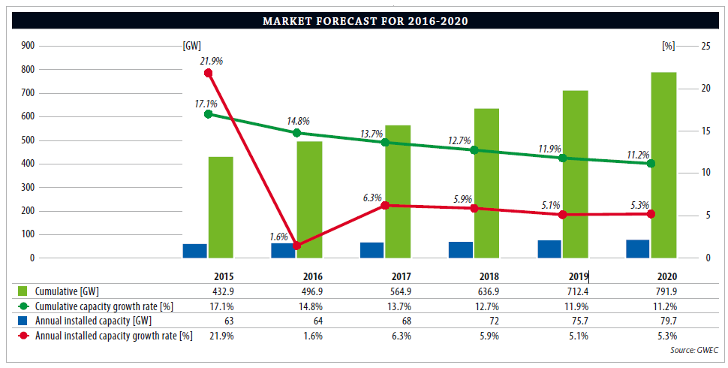

Fig. 1‑3. Global wind energy market forecast [7]

It can be concluded that from wind power capacity installation performance and financial growth support to newly installed wind power plants in the last decade, Turkey shows some promise to become in top 5 countries of wind energy capacity in next years.

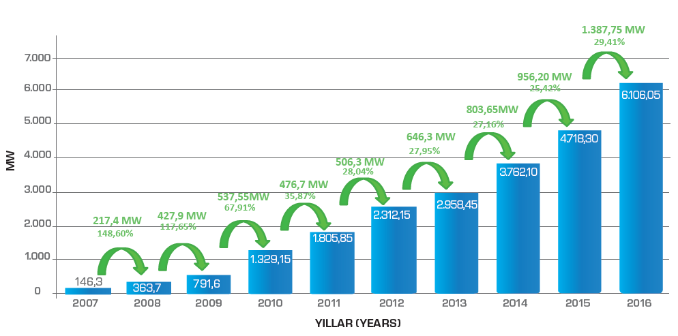

Fig. 1‑4. Cumulative installations for wind power plants in Turkey [10]

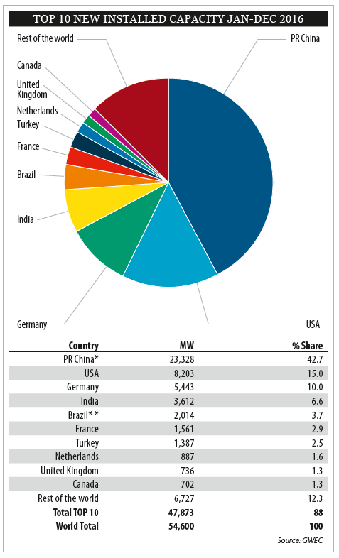

Fig. 1‑5. Top 10 new installed WPP(Wind Power Plant) capacity between January-December 2016 [23]

Wind turbine design is an important issue for renewable energy. Especially for the last decade its technology is substantially matured with variable speed applications. Although there are physical and aerodynamical limitations due to natural causes of wind phenomenon, different arrangements of wind turbine generator systems are invented to maximize the captured energy. By this improved technologies both in power electronics and generators, manufacturing and installation costs are reduced. Therefore, wind energy harvesting concepts started to penetrate the global markets. According to [2] the global installed utility scale wind power was 197 GW at the end of 2010 (an increase of 24.1%) while the global market for small wind turbines (SWTs) grew by only 4%. Evolution of wind turbine size and power electronics can be seen in Fig. 1-6. As the sizes and power levels of wind turbines are increased, importance of efficiency and grid connection subjects also increased. Because wind power plants gradually becomes inevitable parts of electrical grids in most countries and they are expected to conform grid codes and fault ride through capabilities.

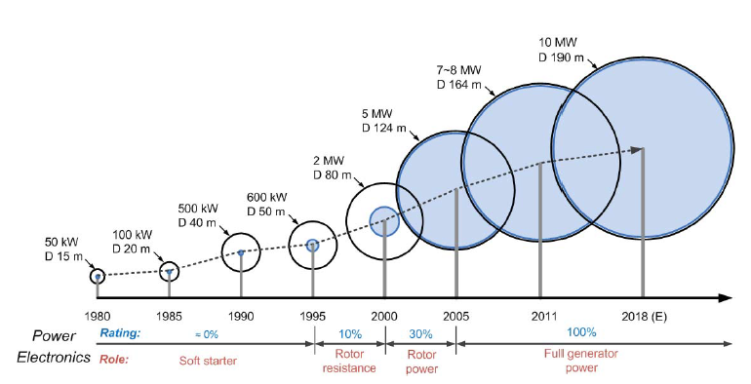

Fig. 1‑6. Evolution of wind turbines [4]

When designing and investing a wind power stations, 3 main properties which are necessary to validate are given as follows:

* Low cost
* Long-lasting
* Low service requirement

These are called L3 conditions [1]. If we go in detail of these conditions from the engineering point of view, lightweight, low cost, low speed, high torque and variable speed operation should be taken into account during the design stage of wind power plant (WPP) [9]. Wind turbine generators dominating the markets nowadays have 300-800 kW power output capacity in average. But the challenges and trends are toward to 1 MW per turbine thanks to promising concepts such as direct-drive [3]. Higher overall efficiency, lower noise, reliability, light weight and reduced maintenance costs are the main advantages of direct drive concept. Direct drive solutions offer simpler and more efficient structures for drivetrain of wind turbines, therefore smaller nacelle can be obtained. Addition to this, using modern rare-earth permanent magnets such as NdFeB, higher energy densities become reachable and more powerful novel generators can be manufactured. One disadvantage of direct drive concept is that they have larger diameters than conventional geared wind turbines in order to provide same output power in low speeds. In this study, direct drive axial flux permanent magnet topology is chosen to design among other topologies. Generators with permanent magnets will be covered more detailed in the next chapter.

Cost per swept area is more valid factor than cost per rated power when evaluating a wind turbine by manufacturers [2]. However, cost per rated power term is used in technical designs and investment planning.

Wind turbines can be categorized in two types according to their rotational axis position:

* Horizontal axis wind turbines (HAWT), example of it is given in Fig. 1-7 (a)
* Vertical axis wind turbines (VAWT) example of it is given in Fig. 1-7 (b)

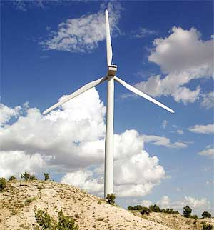 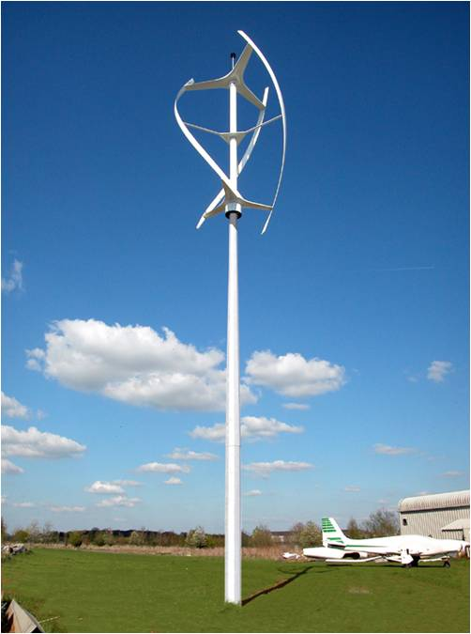

(b)

(a)

Fig. 1‑7. Wind turbine types according to rotation axis (a) horizontal axis (b) vertical axis

As the name refers, in horizontal axis wind turbines axis of rotation of the shaft is parallel with ground while in vertical axis wind turbines shaft axis is perpendicular to ground. Horizontal axis wind turbines are dominant in market due to its robust structure and high overall efficiency. Vertical axis turbines are generally used in small wind applications in levels of kWs. In vertical axis wind turbines angle of strike of the air is inherently varies with the rotation and it’s hard to capture energy especially under unbalanced wind flow conditions, while pitch and yaw control of the turbine can be successfully implemented in horizontal axis turbines. In general, the efficiency of small wind turbines is low compared with large wind turbines [2]. There are no standards about what wind speed manufacturers should give the output power of their turbine (rated power). Therefore, there are some differences between the manufacturer's plate values and actual measured values.

Another important issue is the speed control of these turbine blades in terms of aerodynamic means. At this point two main control techniques are exist: stall control and pitch control. Generally in stall controlled technique, turbine blades are fixed aerodynamic structures and these turbines need high peak torque to limit turbine speed while in pitch control technique, blade pitch angle can be changed during operation of turbine i.e. angle of attack of air can be adjusted therefore these turbines do not need over torque for limit the speed [5]. In variable speed applications pitch control is a commonly used technique [24].

Main parts of the wind turbine consist of turbine blades and shaft, gearbox and the generator. The main generators used in wind turbines are synchronous and induction generator concepts. In conventional applications, gearbox is connected between turbine shaft and generator and used for increasing the low speed of turbine blades to high speed of generator. In direct drive wind turbines, generator directly connected to main shaft of the turbine and operate at low speeds. Geared and direct drive schematics of wind turbines are shown in Fig. 1-8. Wind turbines can be categorized into three main groups according to generator rotational speed. These are fixed speed, limited variable speed and variable speed [22]. Although first examples of wind turbines were generally fixed speed ones like Danish concept, modern wind turbines nowadays use variable speed concept because of higher power and higher torque advantages. More detailed explanations and schematics about categorizing wind turbines according to their drivetrain, generators and flux orientations will be given in the next chapter.

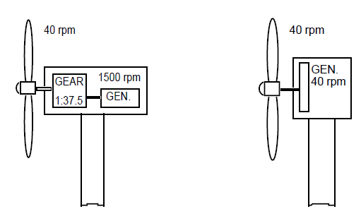

Fig. 1‑8. Conventional geared (left) and direct drive wind turbines [6]

(a)

(b)

## Problem Statement and Research Objective

As the wind energy conversion systems become more capable player of the global energy sector and installed capacities of the WECs increased every year, reliability for these systems becomes more important issue. Especially with the increased power rates of these turbines, size and volumes are also increase and modularity becomes vital.

In this thesis work, a Direct Drive Axial Flux Permanent Magnet wind turbine generator is chosen and designed because of its high torque density and volume advantage. Designed and proposed generator has output power of 5 MW. Gearless drive train is chosen especially for increase overall efficiency and reduce maintenance costs. Proposed generator also has a modular structure, thus reliability and high efficiency is desired even in a fault-state. Parameters of the designed machine will be chosen according to genetic algorithm optimization and FEA validation. Also in this study, proposed generator system is compared with its MW level counterparts. Table 1-1 shows the recent MW level wind turbine models with respect to their brand, model, origin, generator type and output power [12]-[21]. Based on these table values, it can be said that trend is going to 10 MW per turbine in a few years. When increasing importance of “reliability”, “modularity” and “fault-tolerance” taken into account, it is expected that the proposed generator system and its comparison with existed commercial counterparts will contribute significantly in the MW level wind energy harvesting technologies.

|  |  |  |  |  |
| --- | --- | --- | --- | --- |
| Brand | Model | Origin | Turbine Power(MW) | Type |
| Sinovel | SL5000/128 | China | 5 | DFIG |
| Sinovel | SL5000/155 | China | 6 | DFIG |
| Vestas | V105/V112/V117/V126/V136 | Denmark | 3.45 | PMSG |
| MHI-Vestas | V164-8.0 MW | Denmark | 8 | PMSG |
| GE Wind | 3.8-130 | US | 3.8 | DFIG |
| GE Wind | 3.6-137 | US | 3.6 | DFIG |
| GE Wind | GE 4.0 | US | 4 | DD PMSG |
| Nordex | N131/3600 | Germany | 3.6 | DFIG |
| Nordex | N117/3600 | Germany | 3.6 | DFIG |
| Siemens Wind | SWT-3.6-130 | Germany | 3.6 | DD PMSG |
| Siemens Wind | SWT-8.8-154 | Germany | 8 | DD PMSG |
| Enercon | E-126 EP4 | Germany | 4.2 | DD EESG |
| Enercon | E-126 | Germany | 7.58 | DD EESG |
| Gamesa | G128/G132 | Spain | 5 | 2G PMSG |

Table 1‑1. Recent MW level wind turbine generators worldwide [12]-[21]

In this table, it’s intended to pick the comparison candidates according to their output power, which is around 5MW and beyond. Similar investigation was made for Turkish wind energy market focused on turbine manufacturers and TWEA data. According to recent TWEA (TUREB) Statistics, graph of operational wind power plants with their turbine manufacturers in Turkey is given in Fig. 1-9.

Output power classification of wind turbines under operation in Turkey is given in Table 1-2. As it can be seen from table, general wind energy profile of Turkey is mostly based on mid-MW levels of 1-2 MWs per turbine. Therefore it can be said that 5 MW output power per wind turbine is a new concept maybe not for global market but for Turkey.

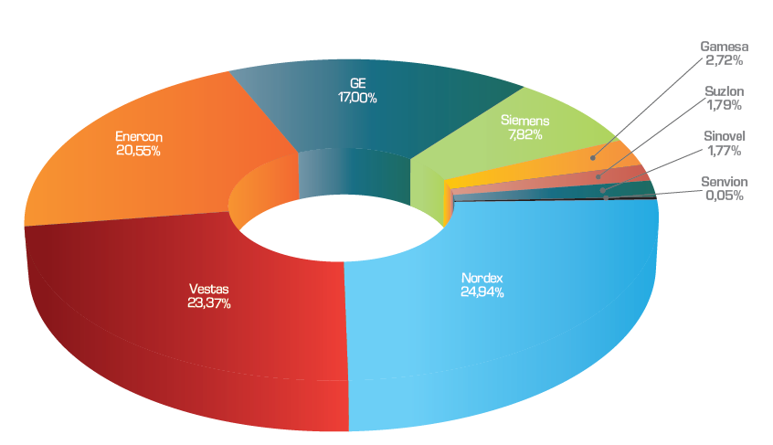

Fig. 1‑9. Operational wind power plants with their turbine manufacturers in Turkey [10]

|  |  |  |
| --- | --- | --- |
| **Output Power<2 MW** | **2MW< Output Power <3 MW** | **3MW< Output Power <4MW** |
| Enercon E-70 | SUZLON S95 | GE 3.2-103 |
| Enercon E-40 | SUZLON S88 | SIEMENS SWT-3.2-108 |
| Enercon E-48 | NORDEX N117 | SIEMENS SWT-3.2-113 |
| Enercon E-44 | NORDEX N90 | VESTAS V112-3.3 |
| Enercon E-82 (2 MW) | NORDEX N100 | VESTAS V126-3.3 |
| Enercon E-53 | SIEMENS SWT-2.3-101 | SENVION 3.4M104 |
| VESTAS V100-2.0 | SIEMENS SWT-2.3-108 |  |
| VESTAS V44-600 | GE 2.75-103 |  |
| VESTAS V90-2.0 | GE 2.85-103 |  |
| VESTAS V90-1.8 | GE 2.5-100 |  |
| VESTAS V52-850 | GE 2.75-100 |  |
| VESTAS V110-2.0 | Enercon E-92 |  |
| VESTAS V80-2.0 | Enercon E-82 E2 |  |
| GE 1.7-100 | Enercon E-82 (3 MW) |  |
| GE 1.6-100 | ALSTOM ECO110 |  |
| GE 1.5se | GAMESA G114 |  |
| GE 1.7-103 | VESTAS V90-3.0 |  |
| GAMESA G90 | VESTAS V112 3.0 |  |
| GAMESA G97 |  |  |
| SINOVEL SL1500/90 |  |  |
| SINOVEL SL1500/82 |  |  |

Table 1‑2. Utilized MW level wind turbine distribution in Turkey according to output power

Total installed capacity share of these wind turbine manufacturers in Turkey is given in Fig. 1-10 below. Comparison of proposed generator with existed MW level wind turbines and related benchmarking will be explained in the conclusion chapter.

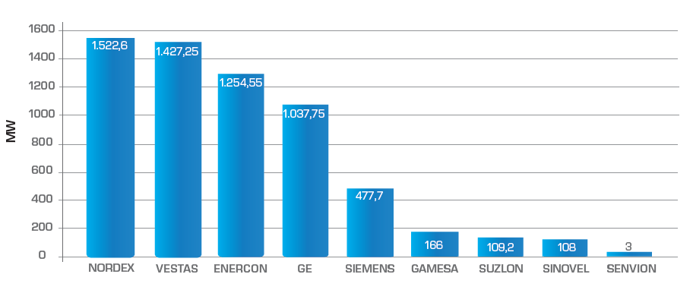

Fig. 1‑10. Total installed capacity share of wind turbine manufacturers in Turkish wind energy market [10]



## Thesis Outline

TBA

**REFERENCES**

**[1]** Kuik, G. A. M. van, J Peinke, R Nijssen, D Lekou, J Mann, JN Sørensen, C Ferreira, et al. 2016. Long-term research challenges in wind energy – a research agenda by the European Academy of Wind Energy. Wind Energy Science 1, no. 1: 1-39. <http://www.wind-energ-sci.net/1/1/2016/>. Accessed: 27/03/2017

**[2]** Ani, S. O., Polinder, H., and Ferreira, J. A. (2013). Comparison of energy yield of small wind turbines in low wind speed areas. IEEE Transactions on Sustainable Energy 4, 42-49.

**[3]** Lampola, P. DIRECTLY DRIVEN , GRID ­ CONNECTED SURFACE ­ MOUNTED PERMANENT ­ MAGNET WIND GENERATOR. 1-6 (2015)

**[4]** F. Blaabjerg and K. Ma, "Future on Power Electronics for Wind Turbine Systems," in IEEE Journal of Emerging and Selected Topics in Power Electronics, vol. 1, no. 3, pp. 139-152, Sept. 2013. doi: 10.1109/JESTPE.2013.2275978

**[5]** A. Grauers, “Design of Direct-driven Permanent-magnet Generators for Wind Turbines” , Phd Thesis, 1996.

**[6]** P. Lampola, “Directly Driven, Low-Speed Permanent Magnet Generators for Wind Power Applications”, Phd Thesis, 2000.

**[7]** GWEC Global Wind Report Annual Market Update Report,2015.

**[8]** The Official Website of Denmark,

<http://denmark.dk/en/green-living/wind-energy/> Accessed: 27/03/2017

**[9]** E. Muljadi, C. P. Butterfield and Yih-Huie Wan, "Axial-flux modular permanent-magnet generator with a toroidal winding for wind-turbine applications" in IEEE Transactions on Industry Applications, vol. 35, no. 4, pp. 831-836, Jul/Aug 1999. doi: 10.1109/28.777191

**[10]** Turkish Wind Energy Statistics Report, Turkish Wind Energy Association (TWEA) , January 2017.

**[11]** Ming Cheng, Ying Zhu, The state of the art of wind energy conversion systems and echnologies: A review, Energy Conversion and Management, Volume 88, December 2014, Pages 332-347, ISSN 0196-8904.

**[12]** The Official Website of Sinovel Wind Group Corporation,

<http://www.sinovel.com/english/list/?43_1.html> Accessed: 27/03/2017

**[13]** The Official Website of Enercon GmbH,

<http://www.enercon.de/en/products/> Accessed: 29/03/2017

**[14]** Vestas Wind Systems A/S,

<https://www.vestas.com/en/products> Accessed: 29/03/2017

**[15]** The Official Website of GE Renewable Energy,

<https://www.gerenewableenergy.com/wind-energy/turbines.html>

Accessed: 29/03/2017

**[16]** The Official Website of Gamesa Corporación Tecnológica,

<http://www.gamesacorp.com/en/products-and-services/wind-turbines>

Accessed: 29/03/2017

**[17]** The Official Website of Suzlon Energy Ltd. ,

<http://www.suzlon.com/products/classic-feet> Accessed: 29/03/2017

**[18]** The Official Website of Nordex SE,

<http://www.nordex-online.com/en/products-services/wind-turbines.html>

Accessed: 03/04/2017

**[19]** Siemens Wind Power GmbH & Corporation,

<http://www.siemens.com/global/en/home/markets/wind/turbines-and-services.html>

Accessed: 03/04/2017

**[20]** The Official Website of Alstom,

<http://www.alstom.com/press-centre/2010/6/Alstom-launches-ECO-100-wind-turbine/>

Accessed: 03/04/2017

**[21]** The Official Website of Senvion S.A. ,

<https://www.senvion.com/global/en/wind-energy-solutions/wind-turbines/>

Accessed: 03/04/2017

**[22]** “Design and Optimization of High Torque Density Generator for Direct Drive Wind Turbine Applications”, MS Thesis, R. Zeinali, METU,2016.

**[23]** GWEC Global Wind Statistics Report,2016.

**[24]** Guidelines for design of wind turbines, DNV , second edition

**[25]** S. Debnath, J. Qin, B. Bahrani, M. Saeedifard and P. Barbosa, "Operation, Control, and Applications of the Modular Multilevel Converter: A Review," in IEEE Transactions on Power Electronics, vol. 30, no. 1, pp. 37-53, Jan. 2015.  
doi: 10.1109/TPEL.2014.2309937

**[26]** S. Debnath and M. Saeedifard, "A New Hybrid Modular Multilevel Converter for Grid Connection of Large Wind Turbines," in IEEE Transactions on Sustainable Energy, vol. 4, no. 4, pp. 1051-1064, Oct. 2013.  
doi: 10.1109/TSTE.2013.2266280

**[27]** P. Samuel, R. Gupta and D. Chandra, "Grid Interface of Wind Power With Large Split-Winding Alternator Using Cascaded Multilevel Inverter," in IEEE Transactions on Energy Conversion, vol. 26, no. 1, pp. 299-309, March 2011.  
doi: 10.1109/TEC.2010.2096538